Assessment Schedule – 2014

Calculus: Apply the algebra of complex numbers in solving problems (91577)

Evidence Statement
Q1 | Expected Coverage |  | Achievement  (u) | Merit  (r) | Excellence (t)
(a) | 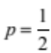 |  | OR equivalent.
(b) | 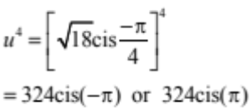 | 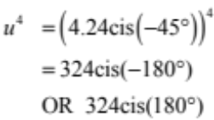 | OR equivalent.
(c) | 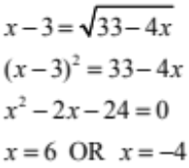  CHECK: x = 6 6 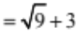 TRUE  CHECK: x = –4 –4 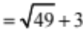 FALSE  Therefore there is one solution: x = 6 |  | x = 6 and –4 both given as solutions.  OR  x = 6 CRO | x = 6 chosen after discarding  x = –4
(d) | 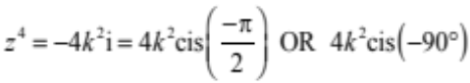  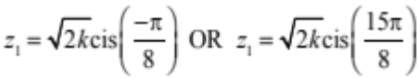  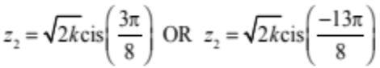  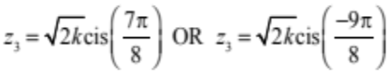  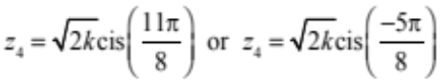 |  | One correct solution.  OR  4 correct arguments in degrees or radians. | All correct solutions given.
(e) | Let z = x + iy  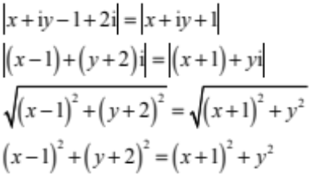  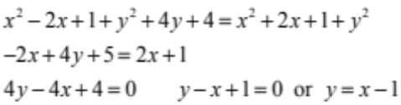 |  | Correct 3rd line. | Correct 5th line.  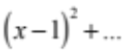 | Correct expression for locus.

NØ |  | N1 | N2 | A3 | A4 |  | M5 | M6 |  | E7 |  | E8
No response; no relevant evidence. |  | 1 partial solution | 1u | 2u | 3u |  | 1r | 2r |  | 1t with 1 minor error |  | 1 t
Q2 | Expected Coverage |  |  |  |  | Achievement  (u) |  |  | Merit  (r) |  | Excellence  (t)
(a) | 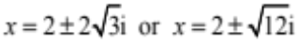 |  |  |  |  | Correct solution.
(b) | 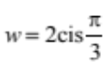  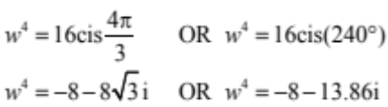 |  |  |  |  | OR  Equivalent rectangular form.
(c) | 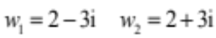  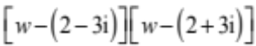  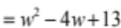  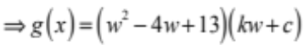  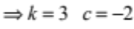  Coefficient of w  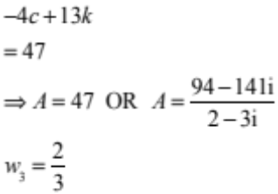 |  |  |  |  | w² – 4w + 13  OR  A = 47  OR  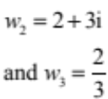  OR  CRO |  |  | Correct value of A and other 2 solutions correct.  A = 47  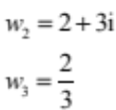
(d)(i)  (ii) | Circle centre (3,4), radius 2  5 |  |  |  |  | Correct locus drawn. |  |  | Correct locus drawn and correct maximum value.
(e) | 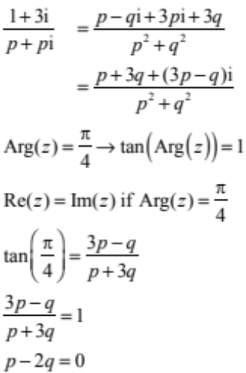 |  |  |  |  | Correct expression without i²  (1st line). |  |  | 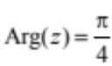  interpreted to give a  correct relationship such as  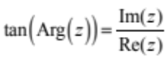 |  | Correct solution.

NØ | N1 | N2 | A3 | A4 | M5 | M6 | E7 | E8
No response; no relevant evidence. | 1 partial solution | 1u | 2u | 3u | 1r | 2r | 1t with 1 minor error | 1 t

Q3 | Expected Coverage | Achievement  (u) | Merit  (r) | Excellence  (t)
(a) | 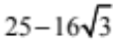 | Correct expression.
(b) | marked correctly on diagram. | Correct point indicated on diagram.
(c) | 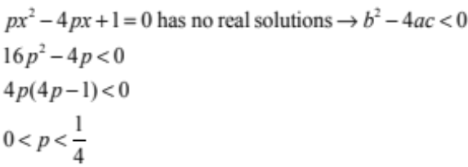 | Correct inequation  (2nd line).  OR  CRO | Correct solution.
(d) | 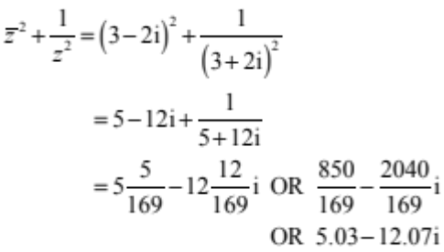 | Correct expansion  (2nd line).  OR  CRO. | Correct expression.
(e)(i)  (ii) | 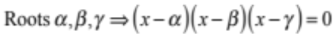  Since ax³ + bx² + cx + d = 0  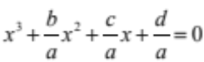  Comparing coefficients  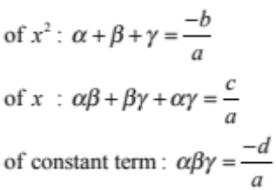  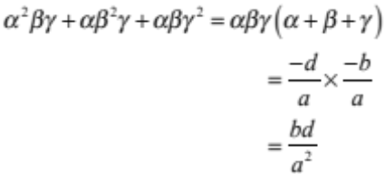 | One correct proof. | 3 correct proofs. | All 4 proofs correct.

NØ | N1 | N2 | A3 | A4 | M5 | M6 | E7 | E8
No response; no relevant evidence. | 1 partial solution | 1u | 2u | 3u | 1r | 2r | 1t with 1 minor error | 1 t

Cut Scores
 | Not Achieved | Achievement | Achievement with Merit | Achievement with Excellence
Score range | 0 – 6 | 7 – 12 | 13 – 19 | 20 – 24

